Scenario 5: Fixed Asset Lifecycle & Year-End Capitalization
- SPRO—IMG—FINANCIAL ACCOUNTING--FINANCIAL ACCOUNTING FOR GLOBAL SETTINGS—LEGERS—PARALLEL ACCOUNTING—ASSIGN ACCOUNTING PRINCIPAL TO LEDGER – create acconting principal
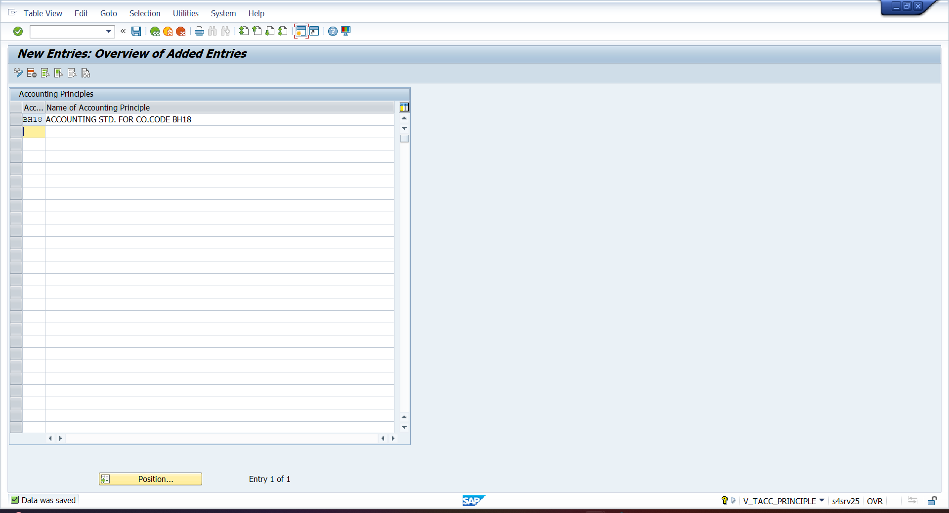
- ASSISGN ACCOUNTING PRINCIPAL
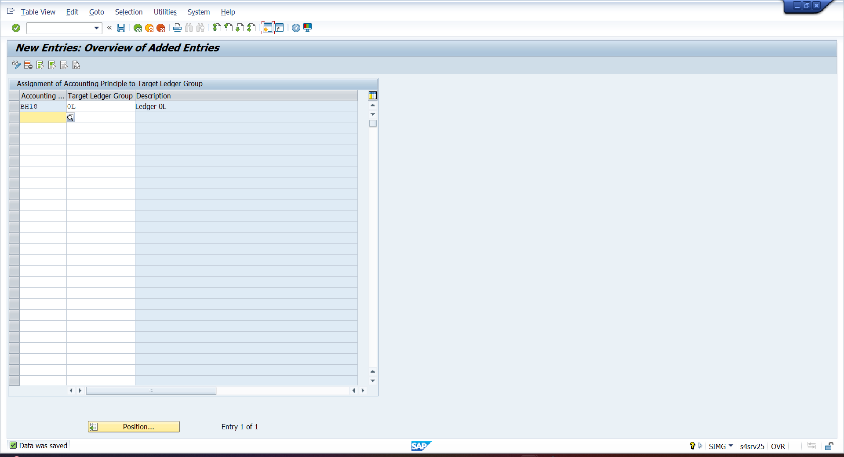

- ASSIGN ACCOUNTING STD. TO LEADING LEDGER
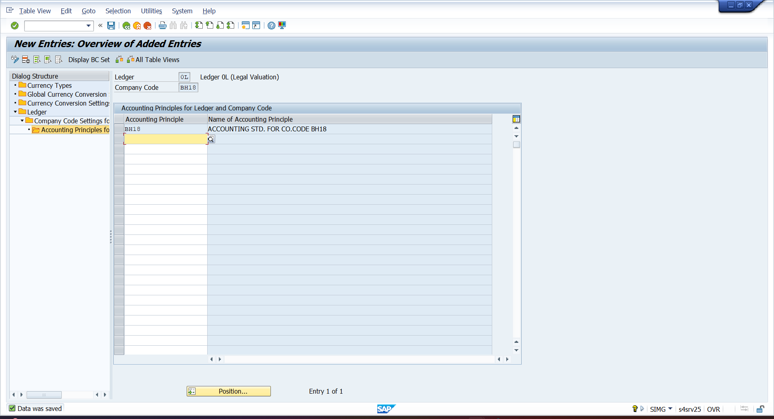
- ORFA—ORANSIATIONAL STRUCTURE—COPY REFERAL—CHATS OF DEPRICIATION
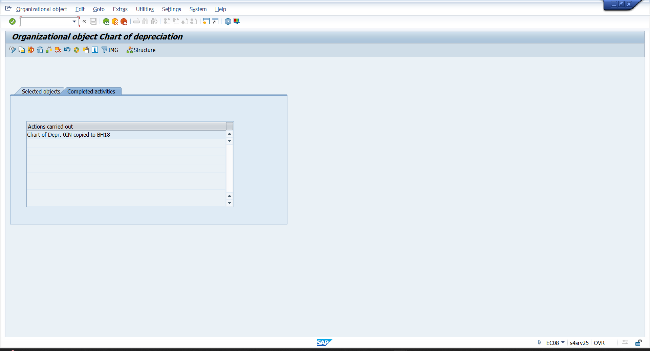

- CREATE CHARTS OF DEPRICIATION
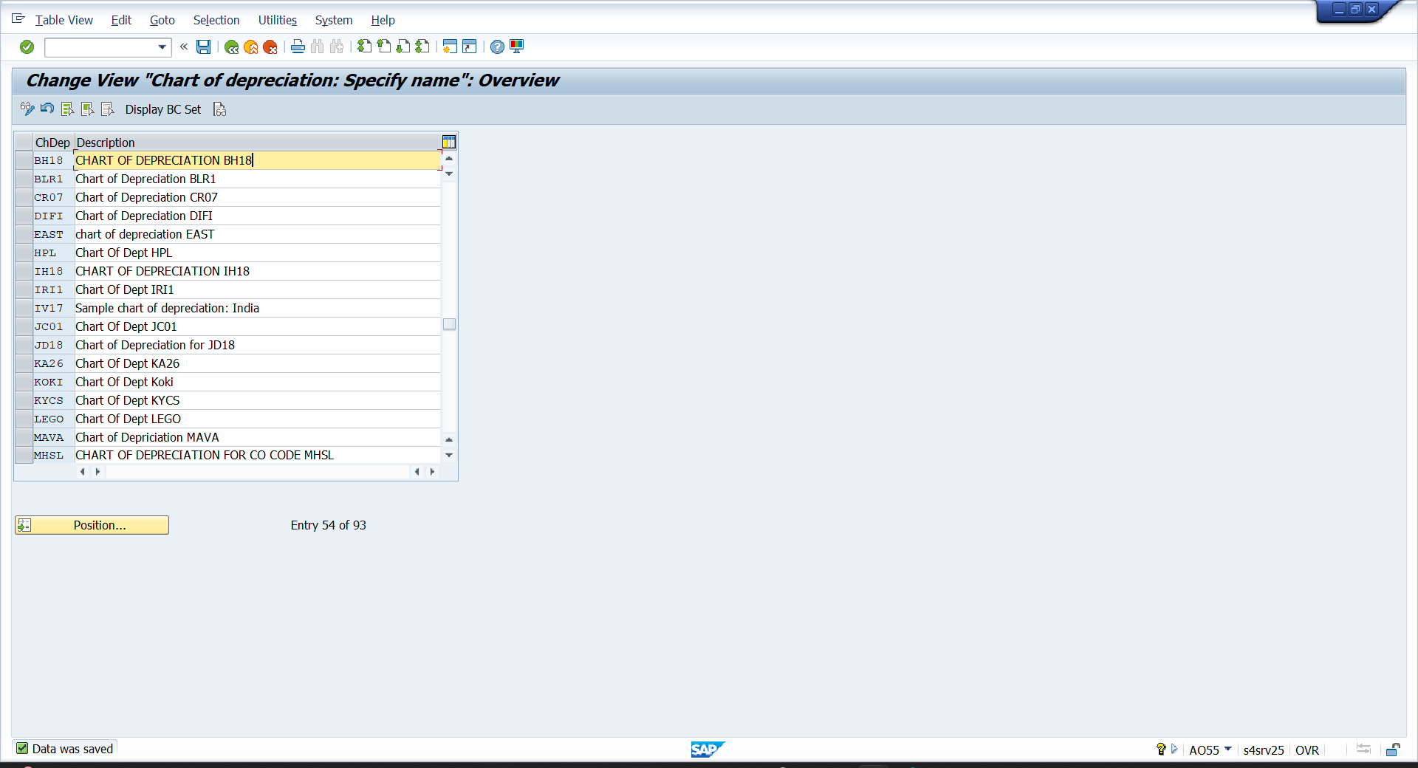
- DEFINE DEPRECIATION AREA
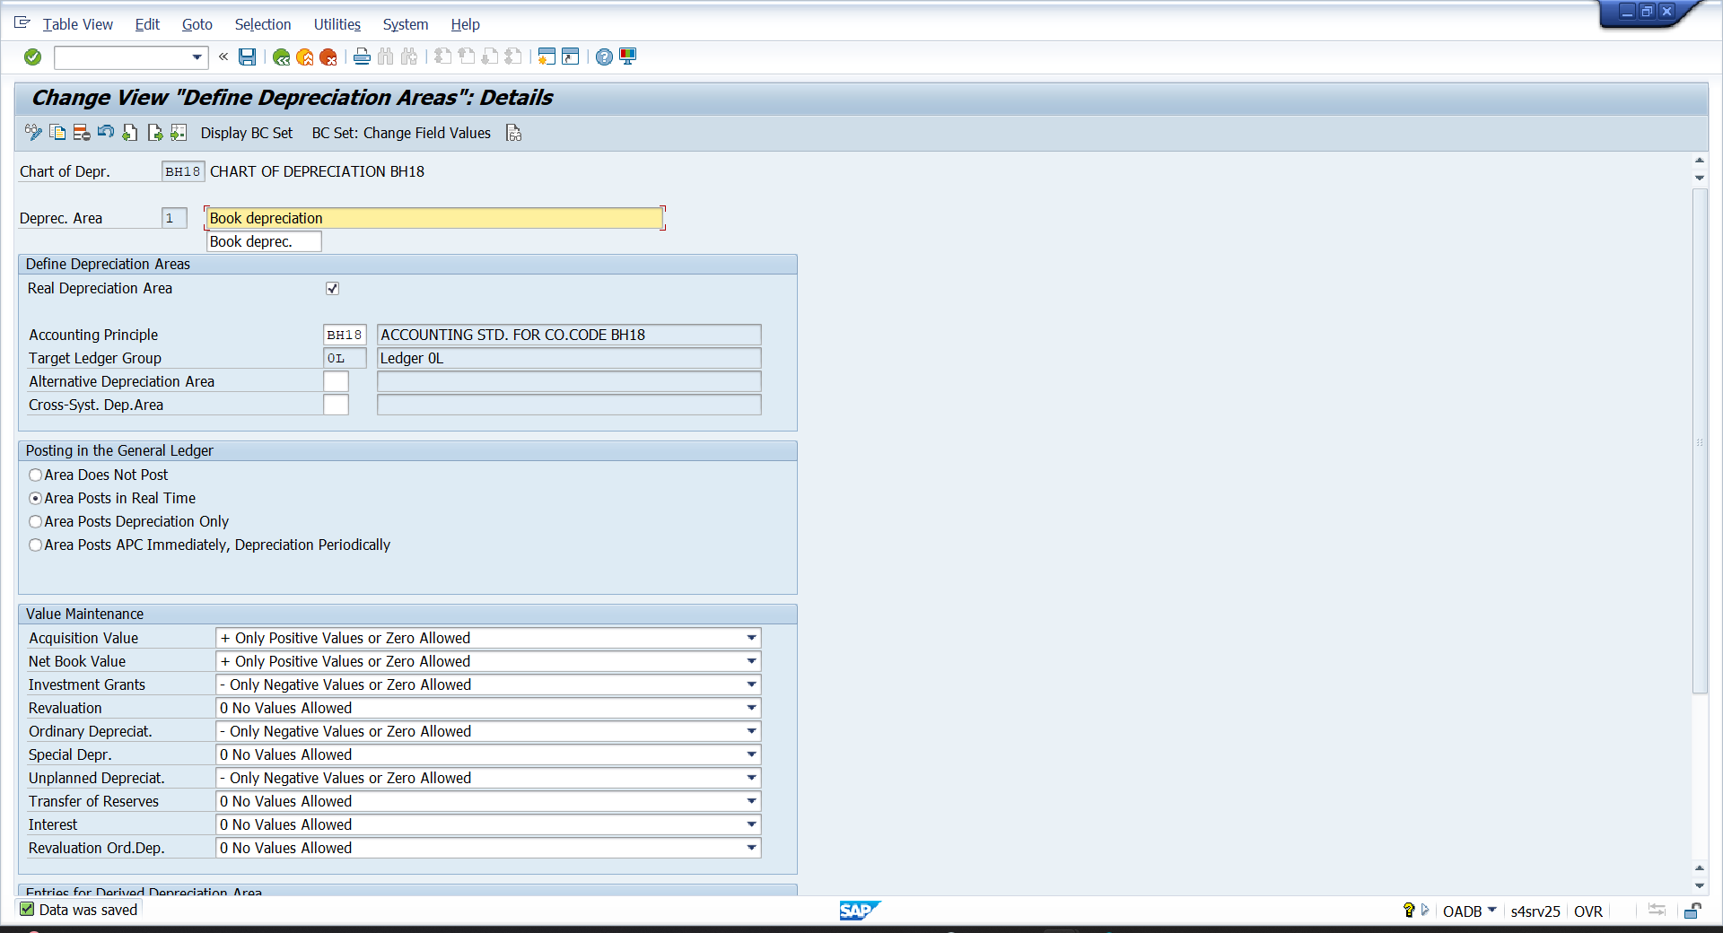

- ASSIGN NON TAXABLE TRANSACTION TO CO.CODE – ORFA—INTEGARTION WITH G/L ACCOUNT—ASSIGN INPUT TAX
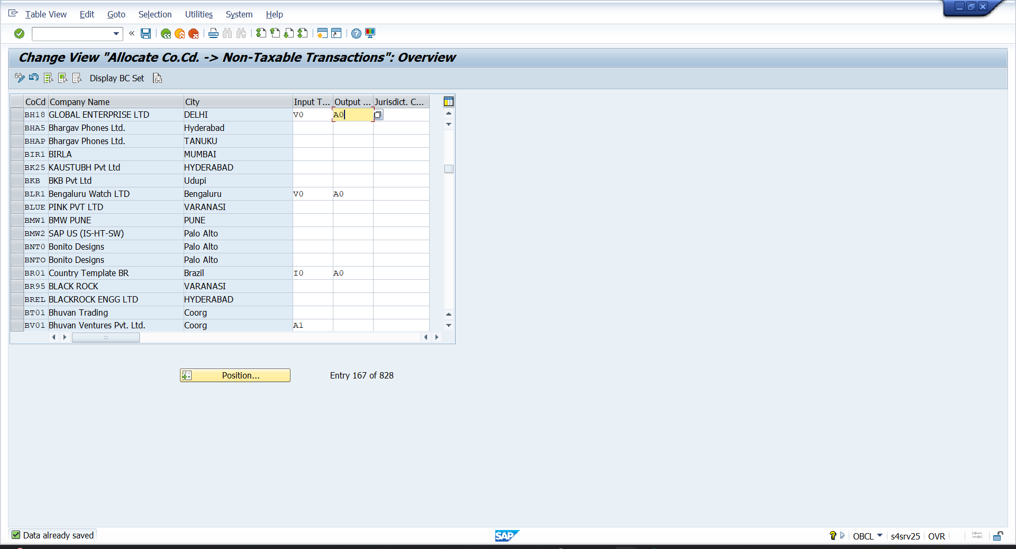
- ASSIGN CHARTS OF DEPRICIATION TO CO.CODE
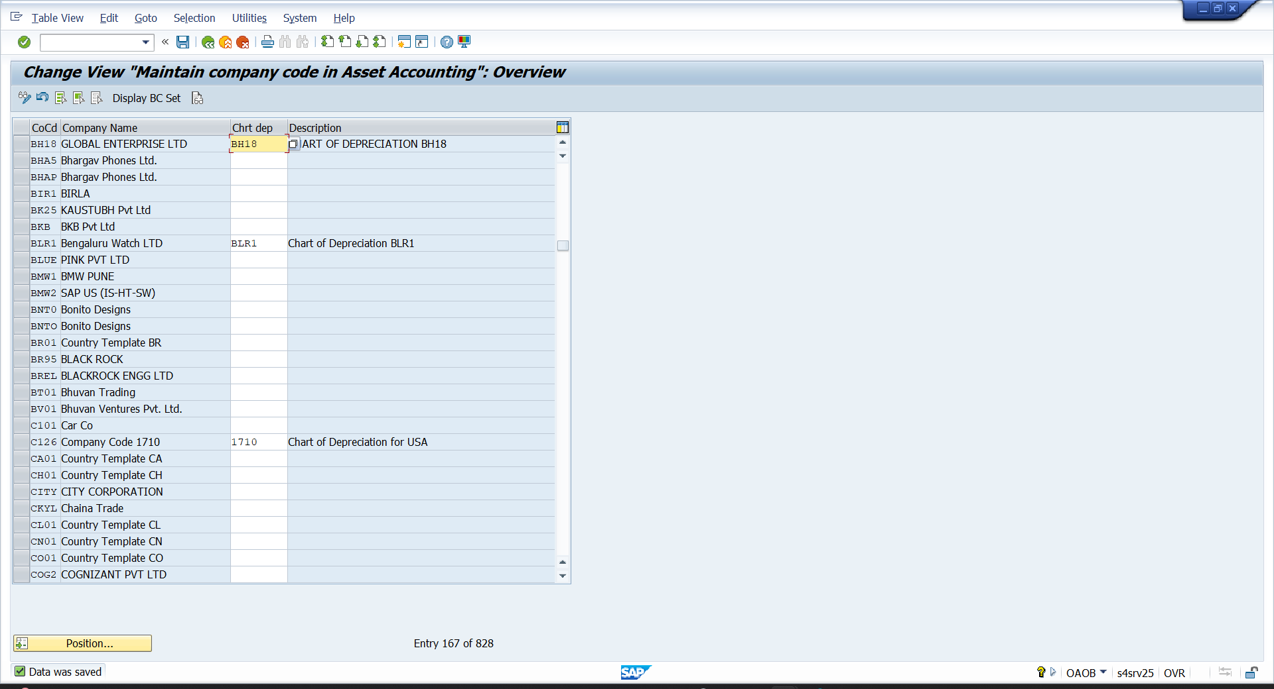

- ACCOUNT DETERMINATION – ORFA –ORGANISTIONAL STRUCTURE—ASSET CLASS—SPECIFY ACCOUNT DETERMINATION
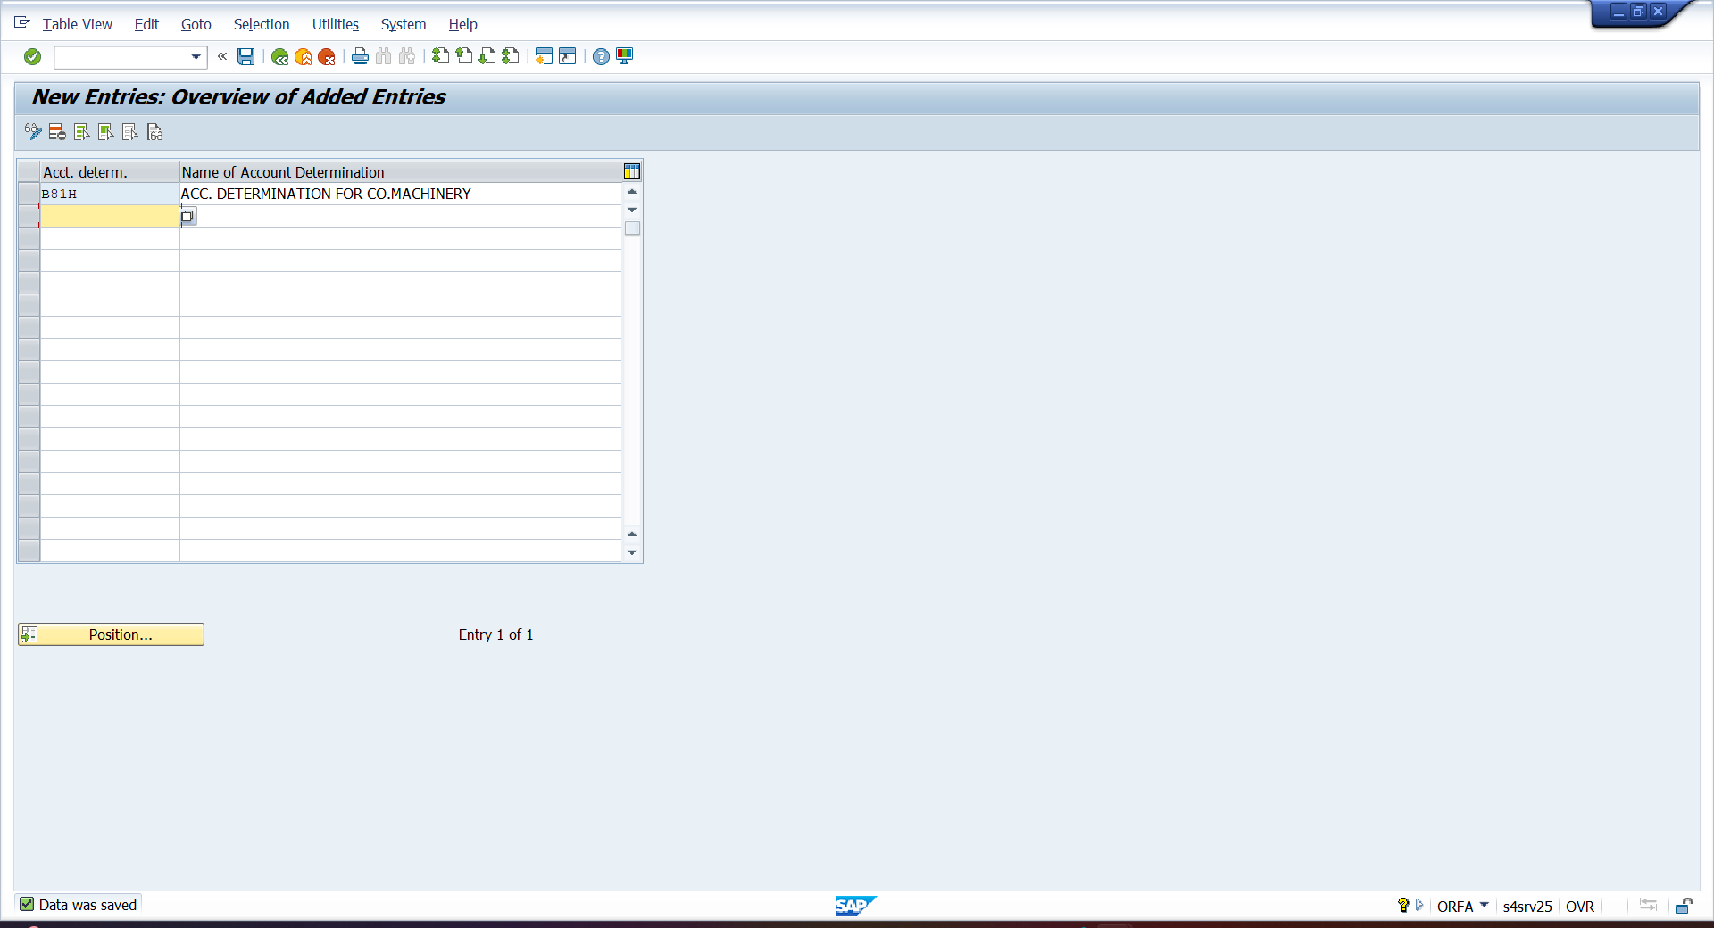
- NUMBER RANGE INTERVAL – ORFA – ORG. STRUCTURE—ASSET CLASS – DEFINE NO.RANGE
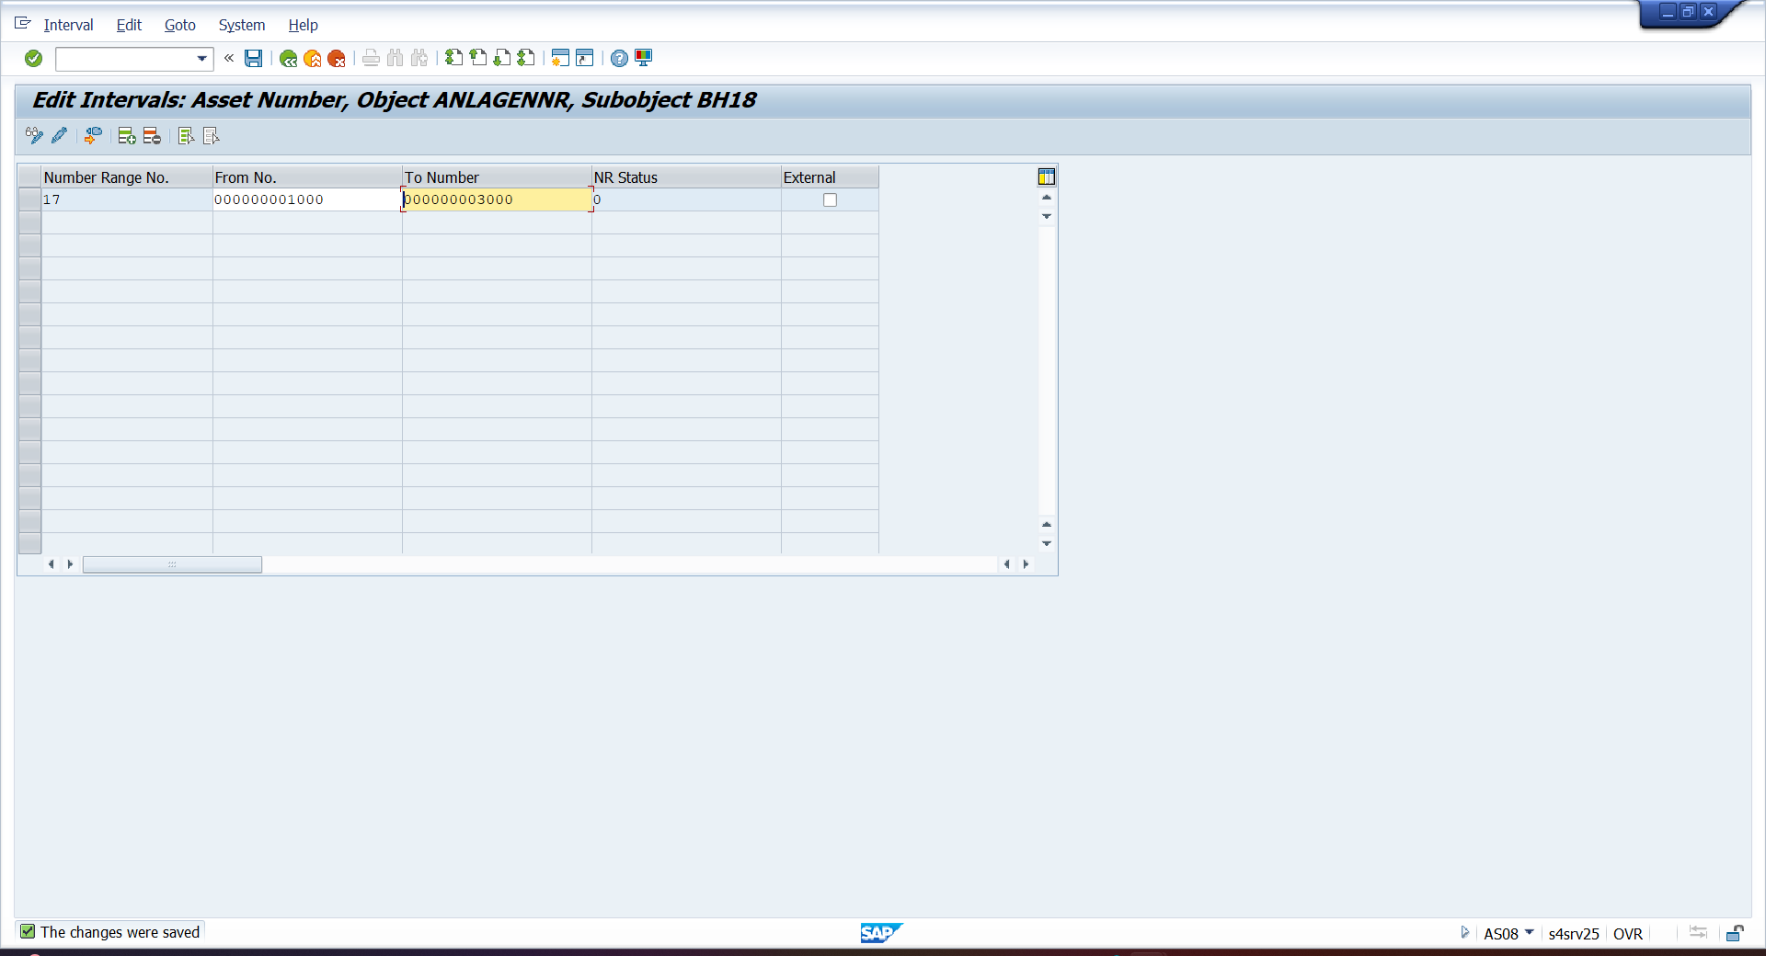

- FS00 – CREATE ASSET G/L AND ACCUMUATE DEPRICATION G/L
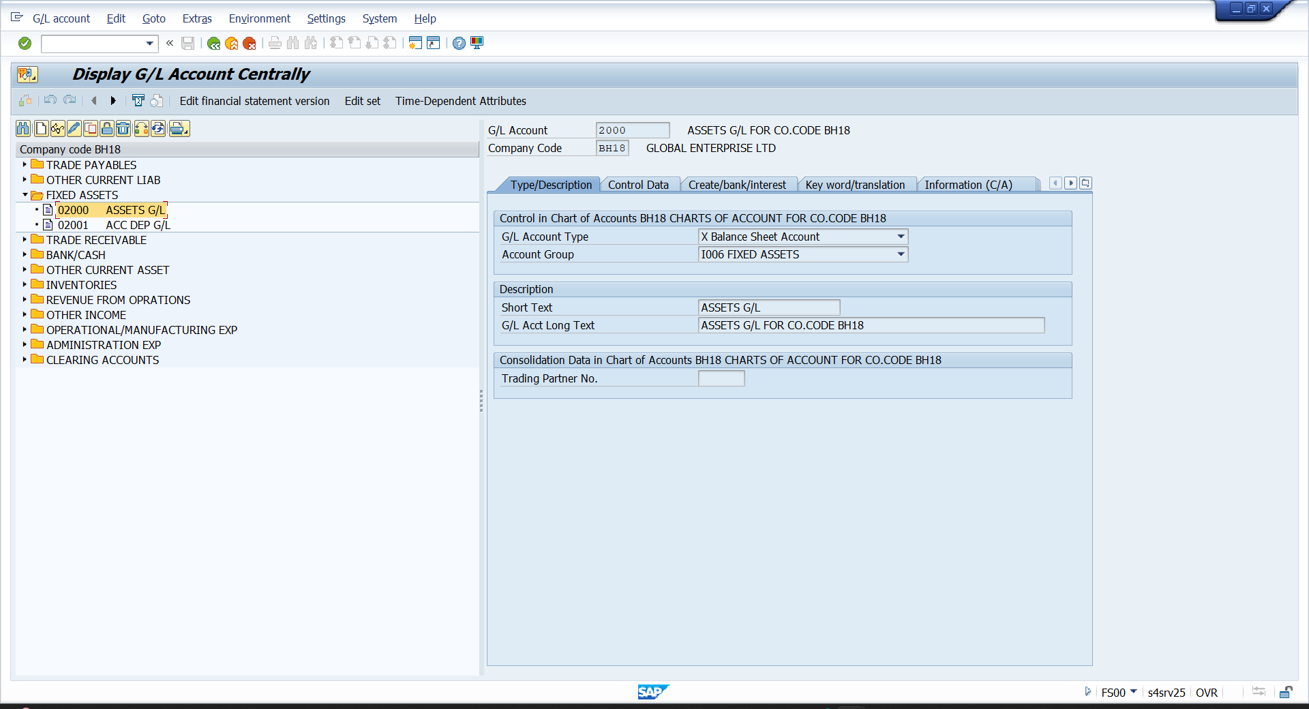

- CREATE DEPRICATION EXPENSE G/L
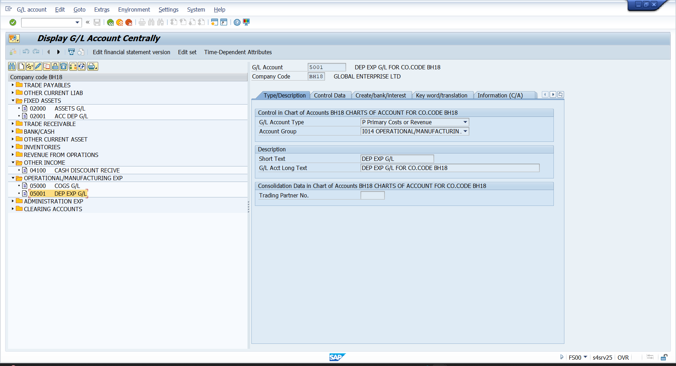

- CREATE SCREEN LAYOUT RULES
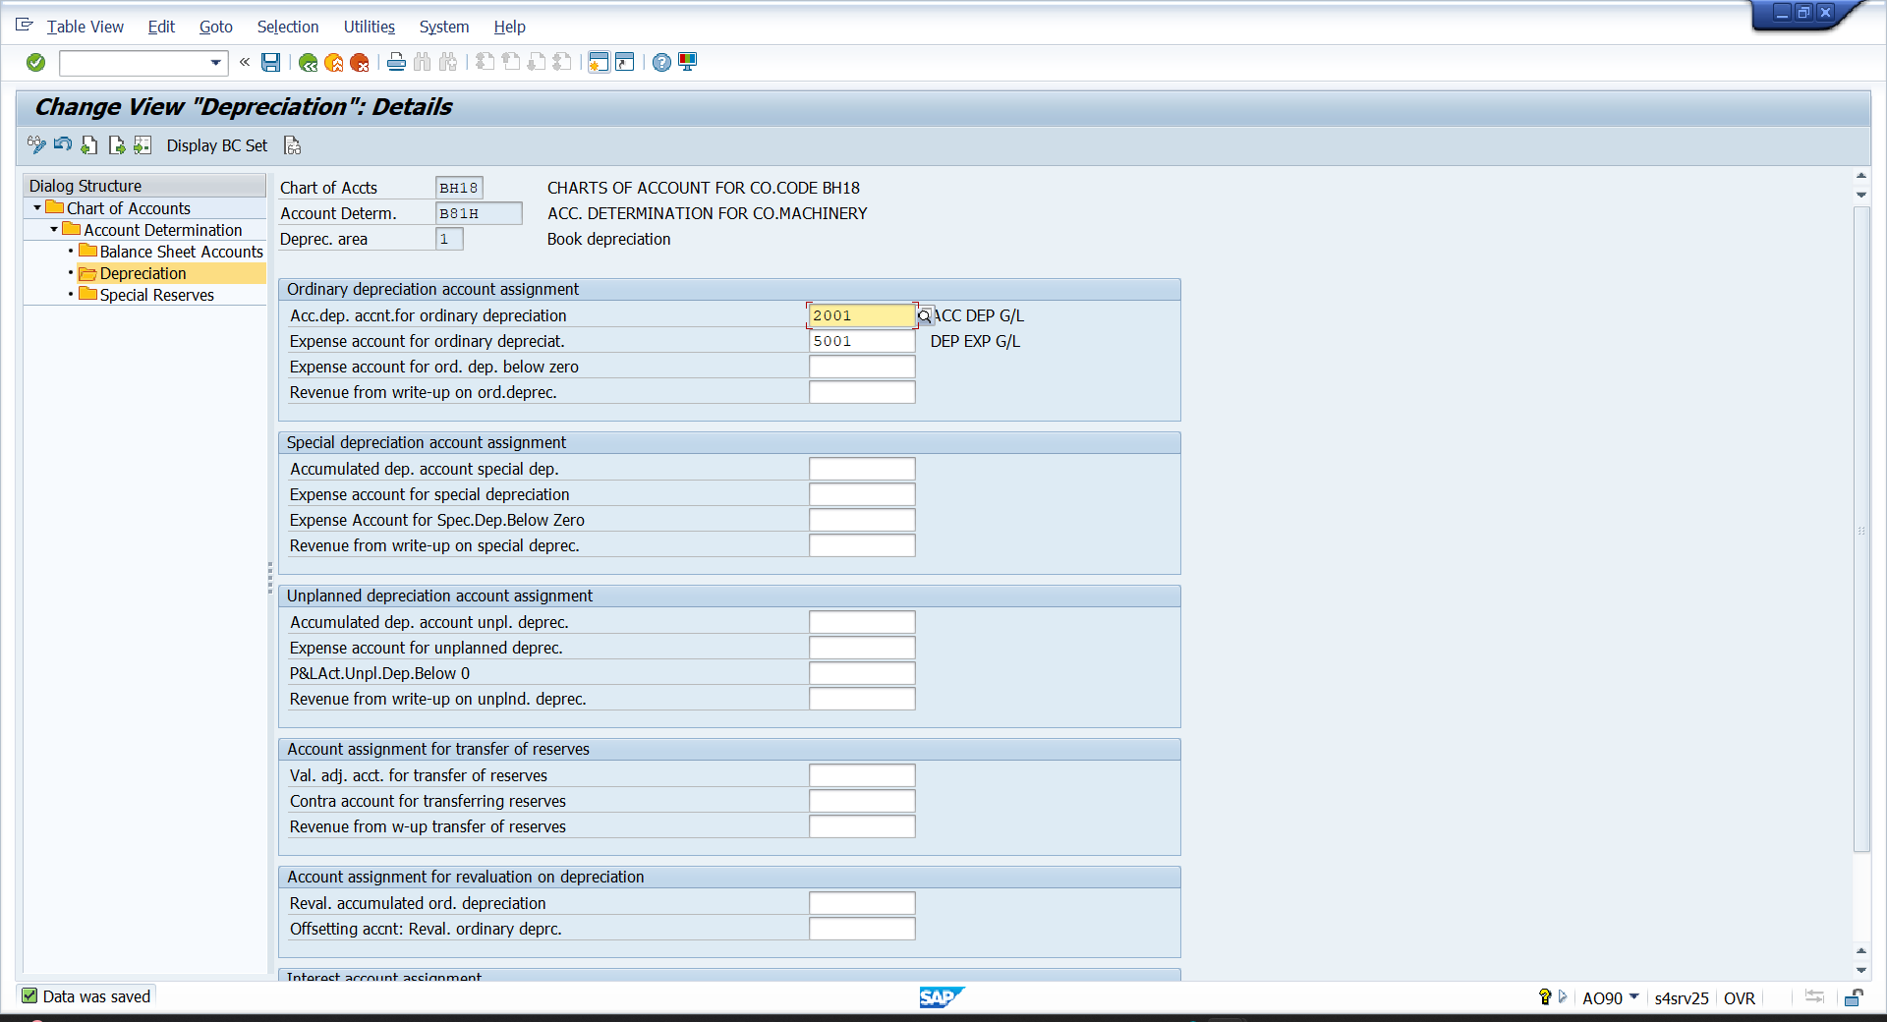

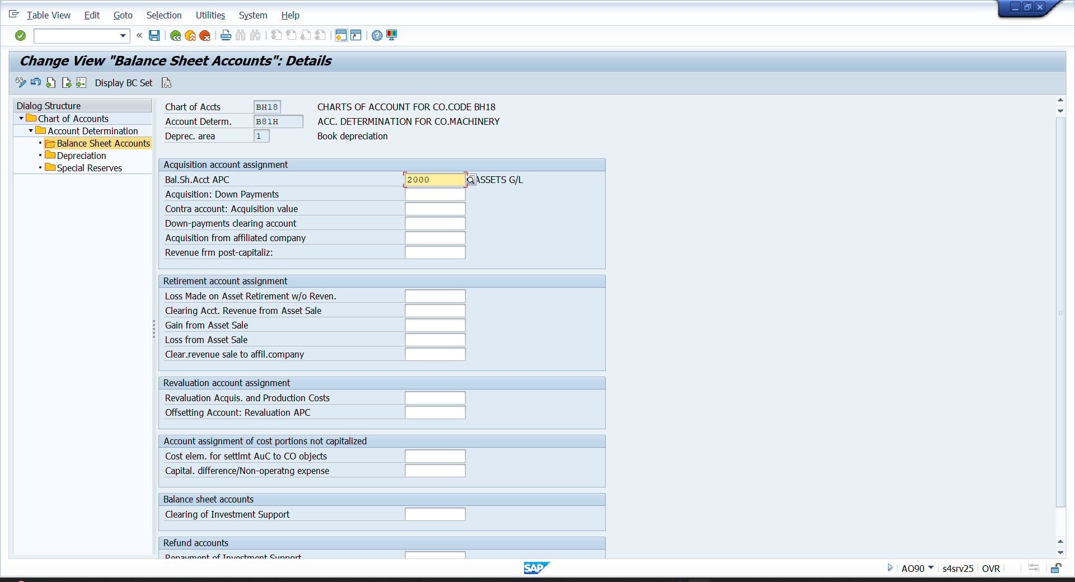

- CREATE ASSET CLASS – ORFA – ORG.STRUCTURE—ASSET CLASS—DEFINE ASSET CLASS
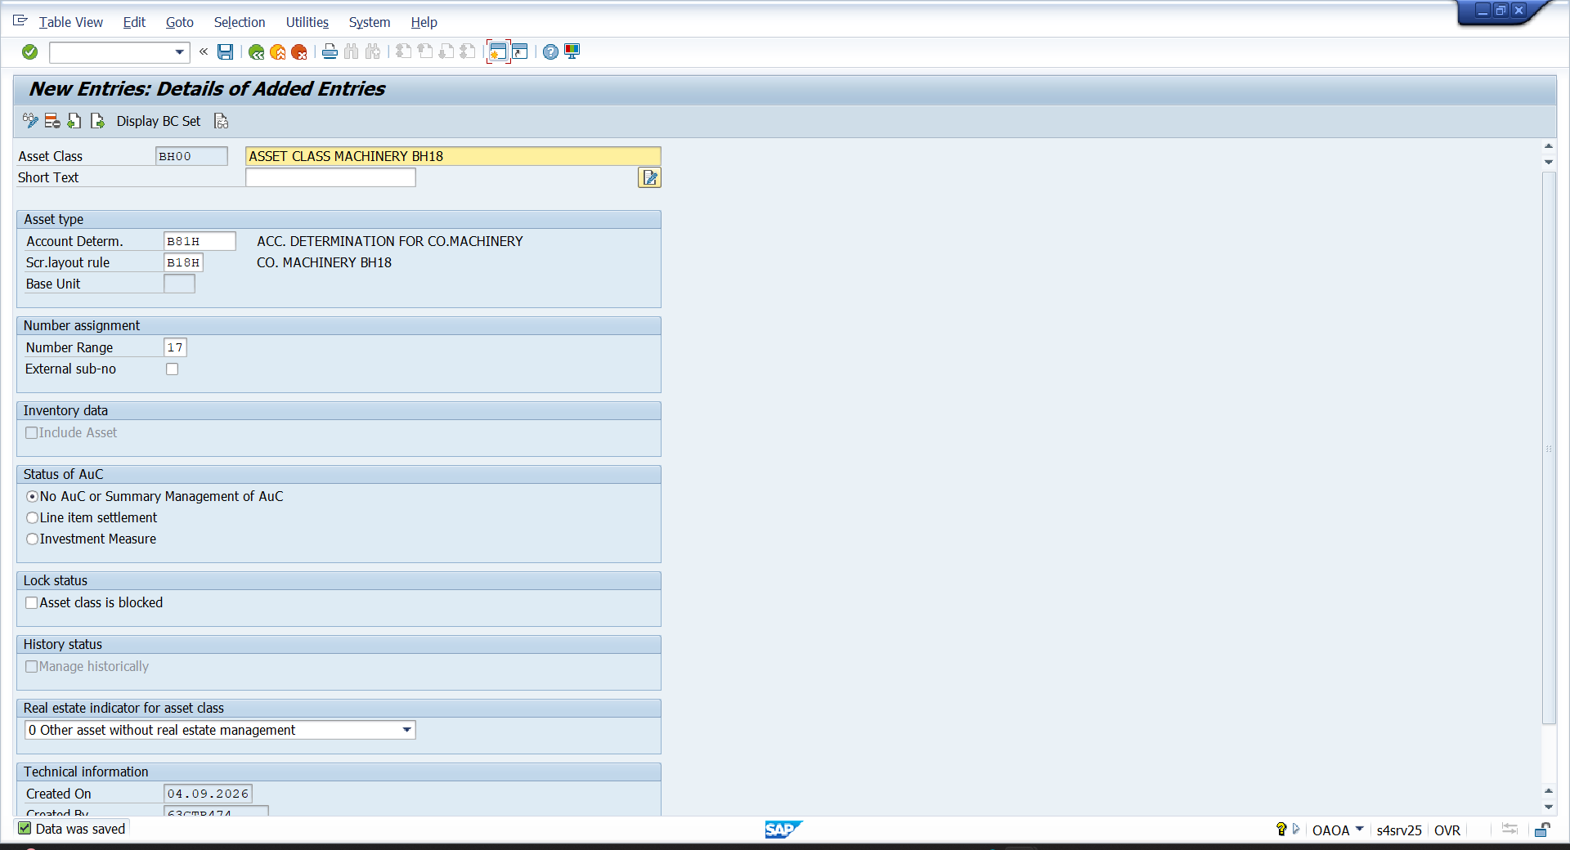

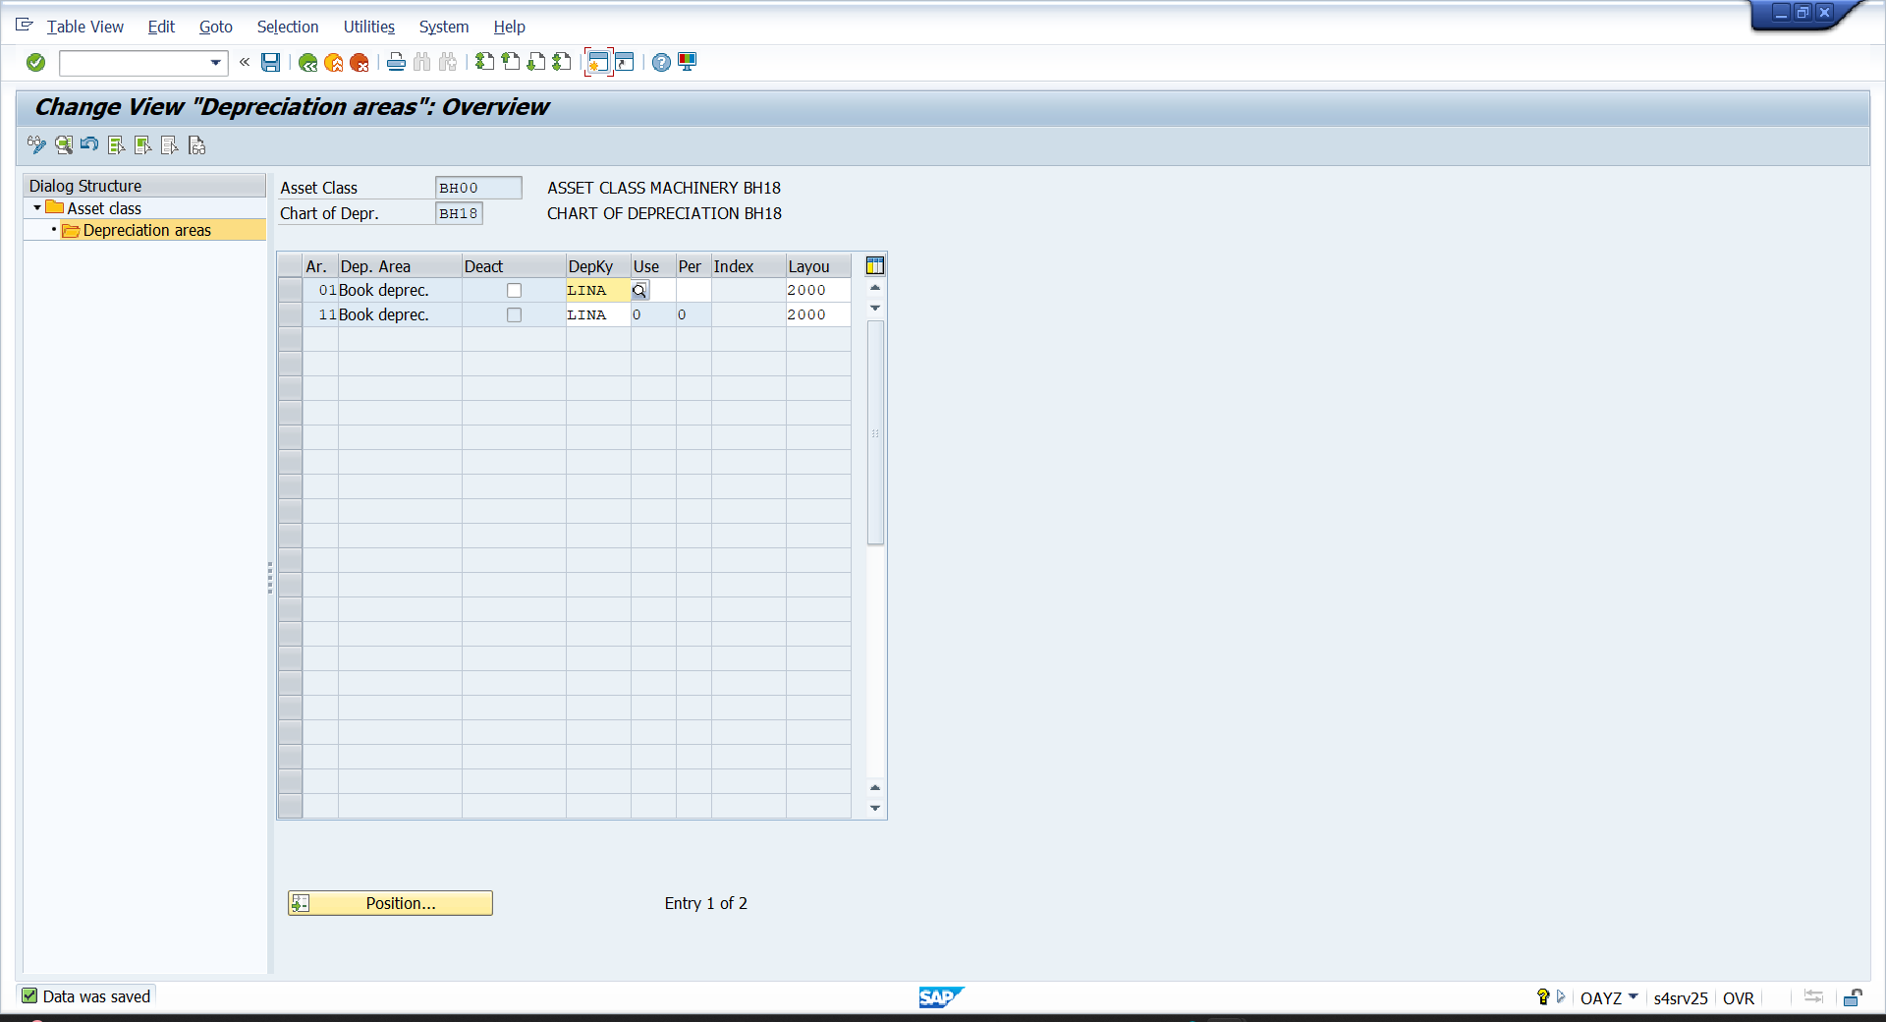

- FS00 – CREATE TECHNICAL CLEARING G/L
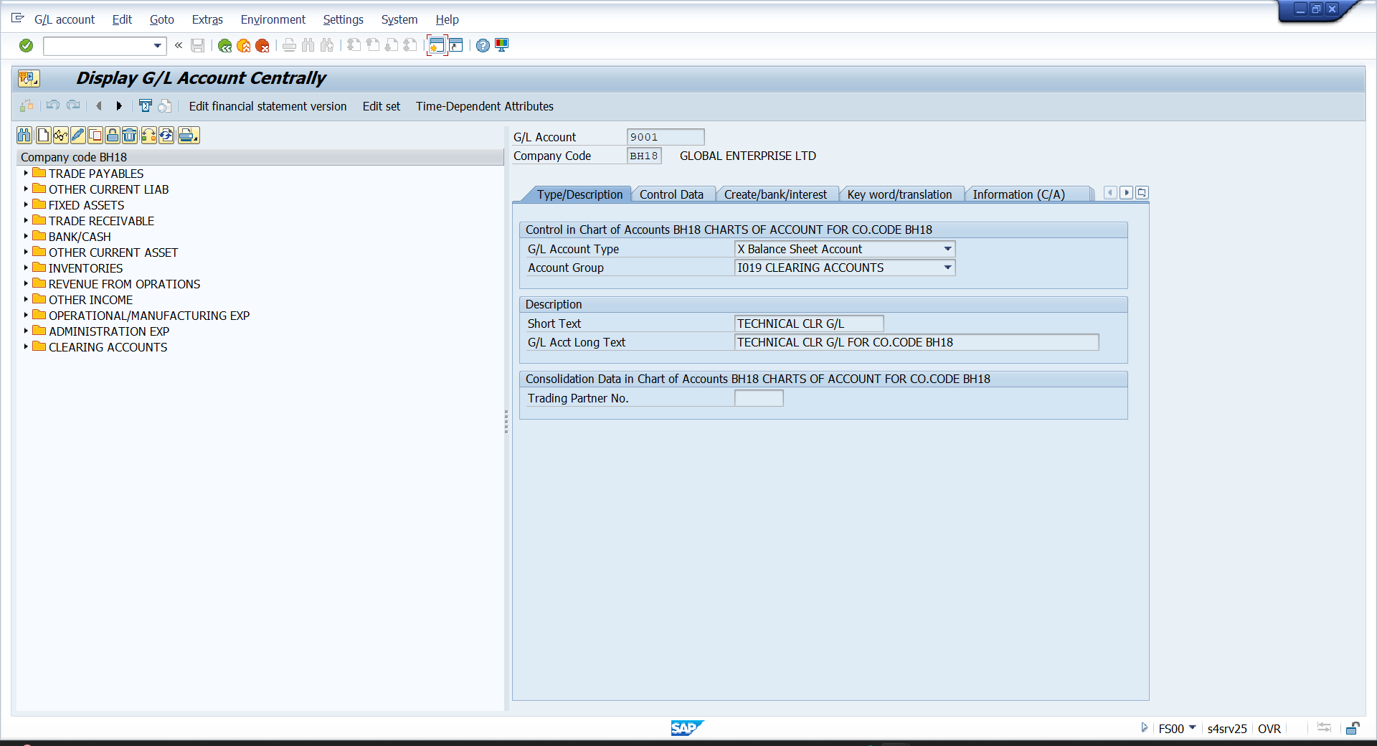

- ASSIGN TECHNICAL CLEARING G/L
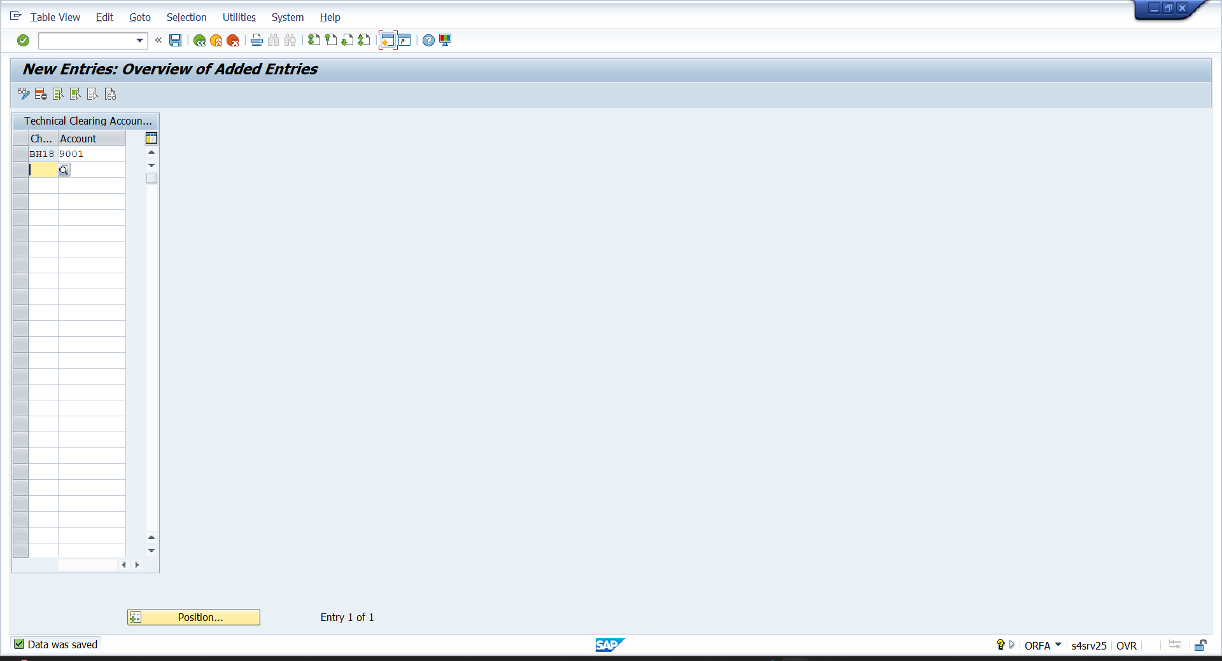

- FAA_CMP – CUTOVER DATE
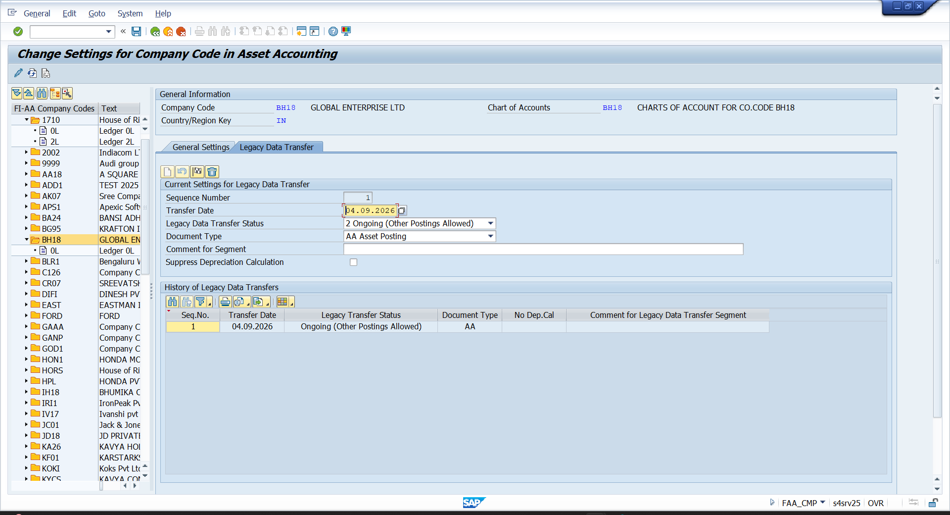
- AS01 – CREATE ASSETS
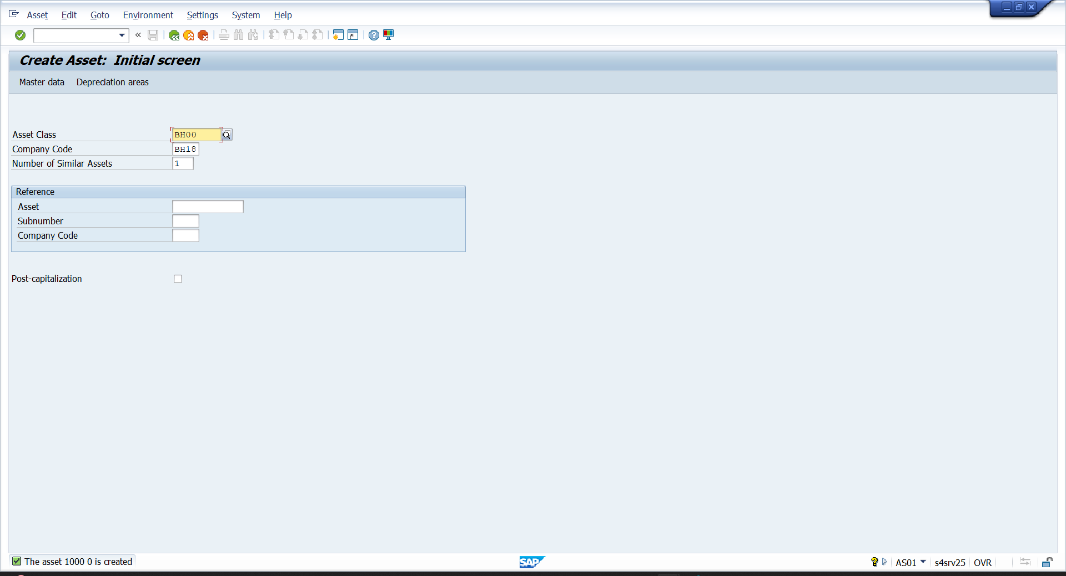

- F-90 – PURCAHSE ASSET
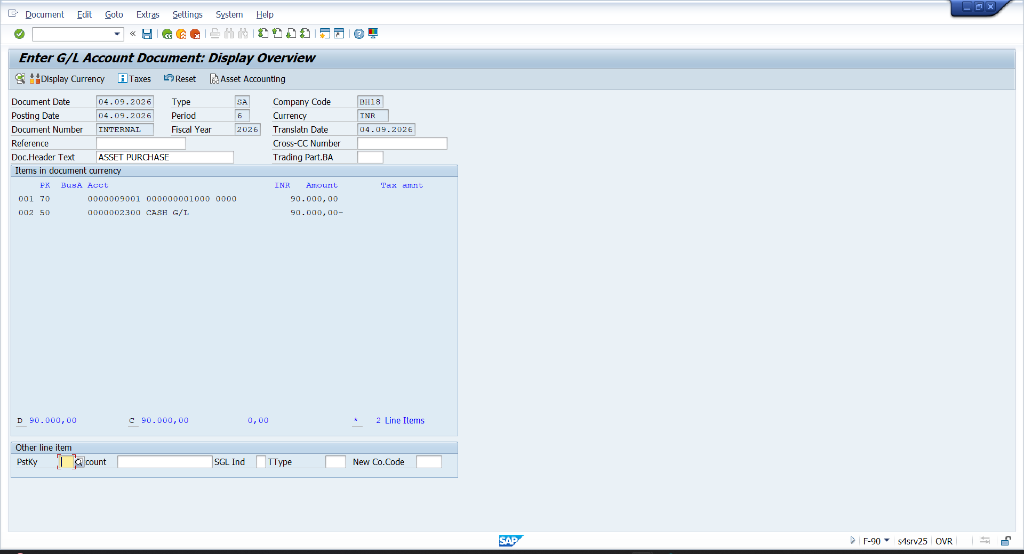

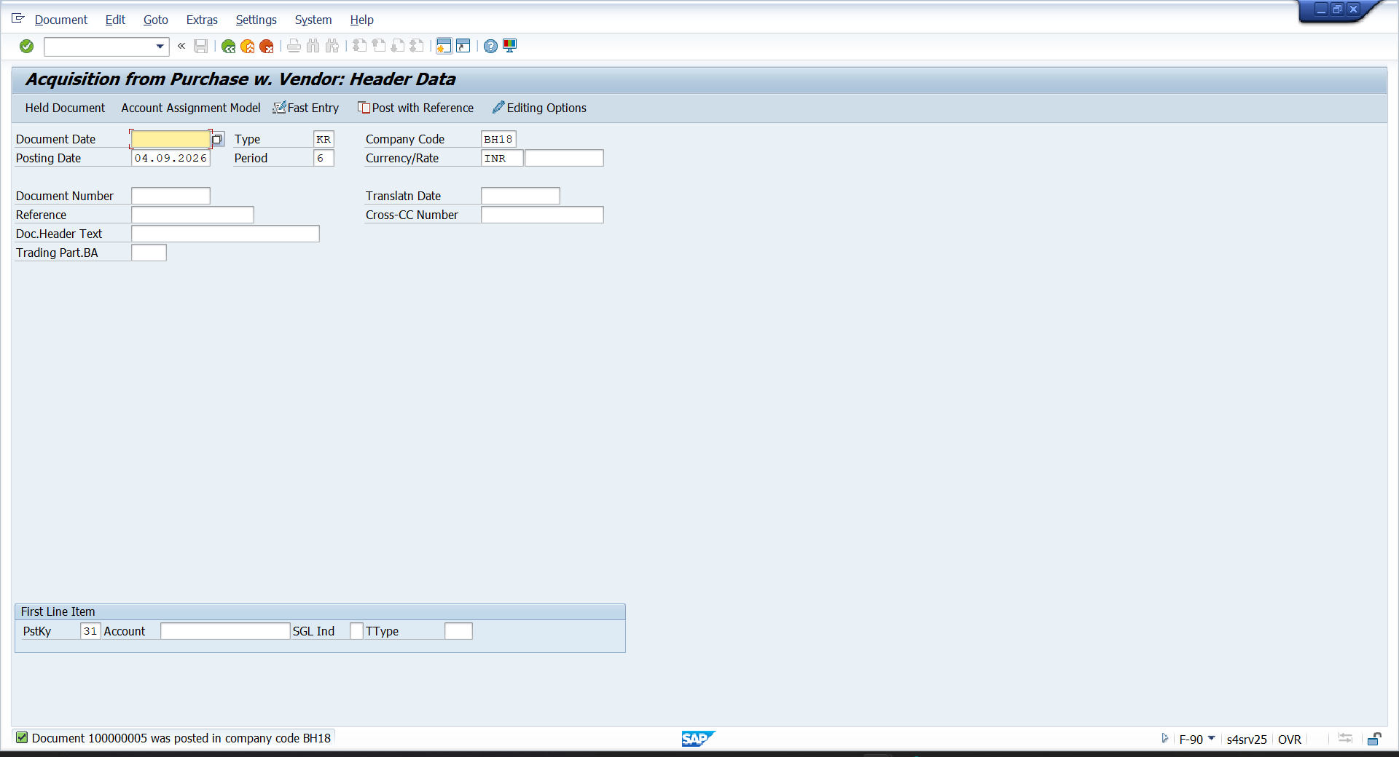

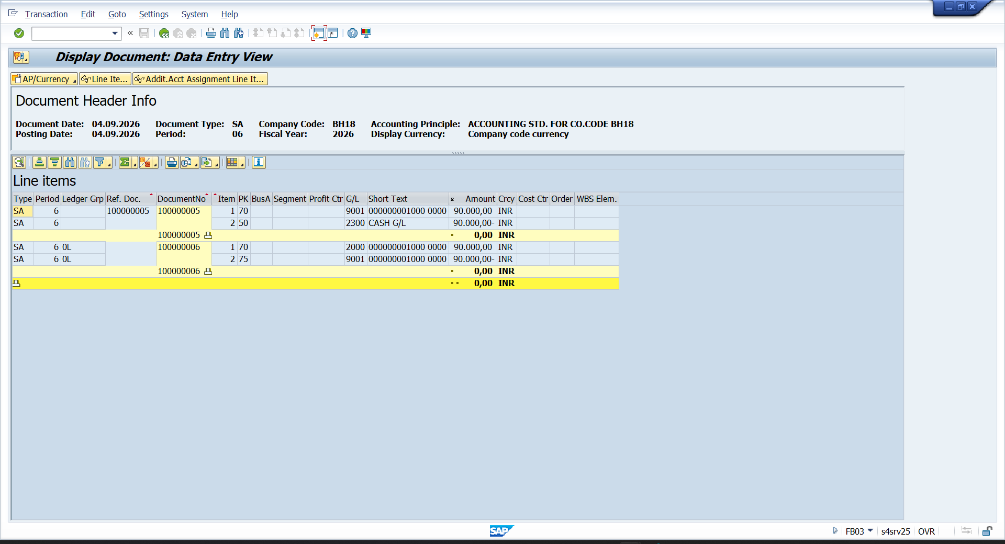
- AW01N – ASSET REPORT
